The Strides for Obesity 3K Walk, October 19th, 2019 route
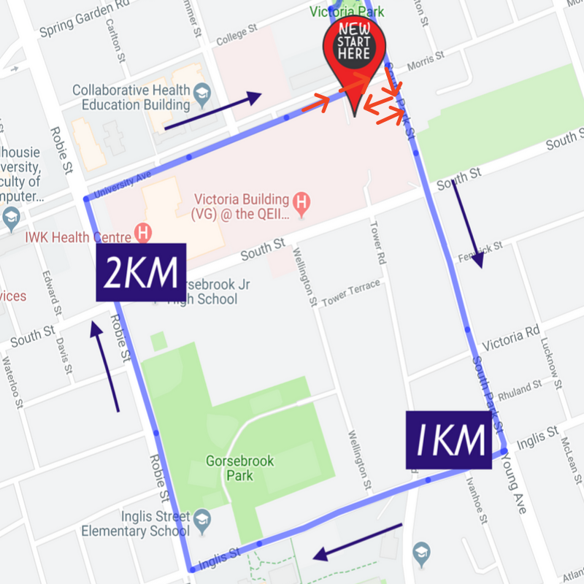
The 2019 Strides for Obesity 3K Route is as follows:
-Start in the Victoria General Parking lot (1276 South Park St) and head directly through the parking lot and exit onto South Park St.
-Then veer to the left onto the sidewalk on South Park St and continue straight staying on the righthand side of the street and continue striding straight on South Park St until reaching Inglis St.
-Once reaching Inglis St, turn right and stroll up enjoying the beautiful morning walk and proceed to Robie St.
-When reaching Robie St, it is time to turn right and celebrate that it is 1/2 way!
-Continue straight on Robie St striding until University Ave.
-At University Ave, turn right again (we won't cross the street) and stay straight until reaching the corner of Morris St and South Park St.
- From there turn left back on to South Park St and stride up to the entrance of the VG parking lot (be careful of cars turning into the lot), back into VG Parking lot and back to the start for your finishers medal and high fives all around!!

